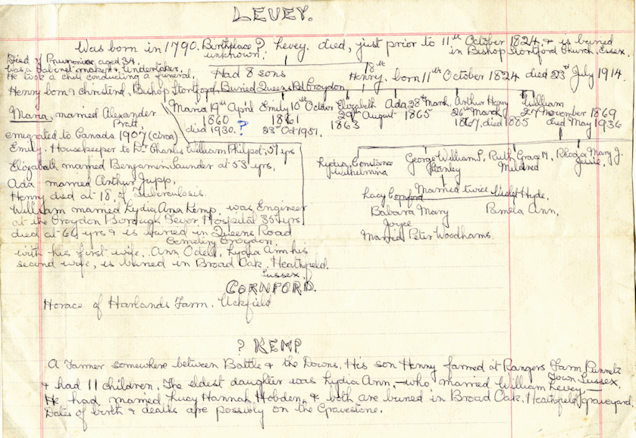

Whilst there is much useful information in this note written by Connie Levey, there are also some inaccuracies. The main inaccuracy is to suggest that Henry Levey was born in 1824. The following are my logical steps to show that he was actually born in 1830.

- In Henry’s 1861 census record, where we know he is the correct person because his wife Jane and daughter Maria are living with him, he gives his age as 30. In subsequent censuses his age gets disproportionately greater until on his death registration he is recorded as being born in 1825. In 1871, 81 and 91 he is 43, 53, 63 respectively. In 1901 he is 76 and in 1911 he is 85. It can be assumed that Connie based Henry's year of birth on his stated age which was not correct.

One fact which seems to have been passed on correctly is that Henry's father died shortly before Henry was born.

It's also reasonable to assume that his birth date, 11th October, was remembered correctly. So I believe Henry was actually born on 11th October 1830. This is supported by the following evidence:

- There is a Henry Levey, the son of James and Elizabeth Levey, who was christened at Little Sampford on 24th April 1831. The record also states that they lived in Stansted. All of Henry’s census records show him being born in Stansted, Essex.

- There is a James Levey, born in 1790, who was buried at St Mary the Virgin church, Stansted Mountfitchet on 17th July 1830.

The date of his death, 23rd July 1914, in this note ties in with the official death registration.